Appointment Broadcast Messages – Program Code SCHBLASTMSG

Purpose: To send a message to patients with scheduled appointments

Procedure:

- Enter the starting and ending dates for the message
- Enter a list of appointment resources to receive the message.
Leave this field blank to include all resources for the selected date(s).
- Enter a list of appointment types to receive this message.
Leave this field blank to include all appointment types on the selected date(s).
- Usually Include ALL appointments, not missed appointments
- EHR Template List: Press <Enter> for ALL
- Enter a Subject and Message in the Broadcast Message appropriate fields
- Select Communication Preference and Methods.
- Click OK to start messaging

Typical Setup for Bad Weather
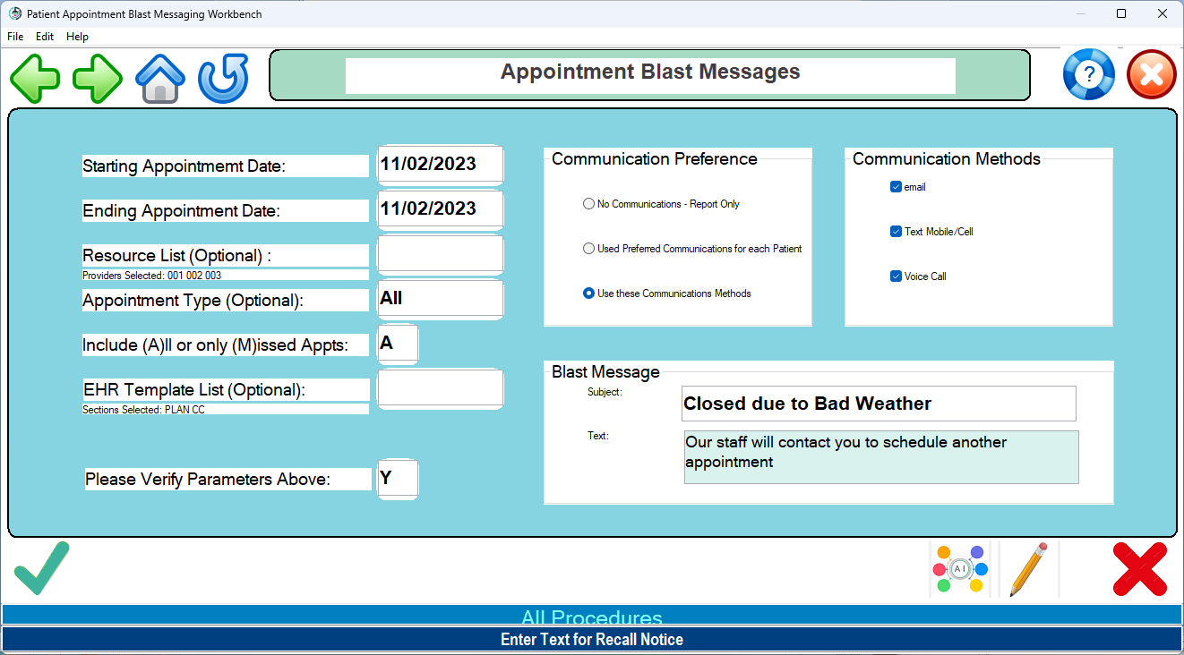

Custom setup for a new patients for resource 005 only


